Old Style ¼ Turn Latch and Key Latch
Old style has ribbs
#EC4151A02 $75.19 #EC4151A02K $78.50
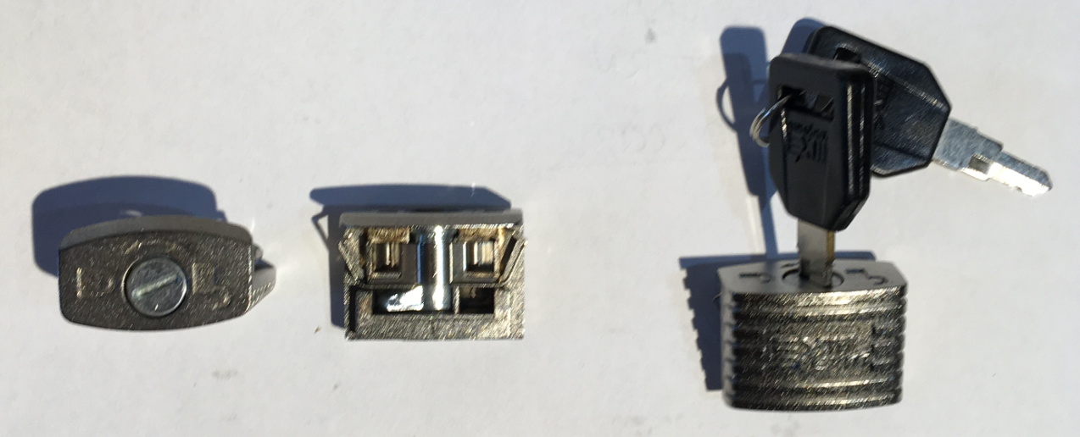

New Style ¼ Turn Latch and Hinge
New Style Does not have ribs
#EC4151A06 $75.25 #EC4151A03 $71.85

